**Abdull Haseeb**

**SU92-BSAIM-F24-050**

**BSAI-3A**

**AI-LAB TASK 4**

**1️⃣ Debit Card Validation (Luhn Algorithm)**

* **The program asks the user to enter a debit card number.**
* **It removes any spaces or dashes from the input.**
* **The card number is then reversed.**
* **Every digit at an odd index (positions 0, 2, 4, … in the reversed number) is directly added to a sum.**
* **Every digit at an even index (positions 1, 3, 5, …) is doubled.**
  + **If the doubled value is greater than or equal to 10, the sum of its digits is added.**
  + **Otherwise, the doubled value itself is added.**
* **The two sums are combined into a total.**
* **If the total is divisible by 10, the card number is printed as “Valid”; otherwise, it is printed as “Invalid”.**
* **This process follows the Luhn Algorithm, which is commonly used to validate debit and credit card numbers.** **Got it Haseeb 👍  
  Here’s the documentation in English (without code) for your three programs:**

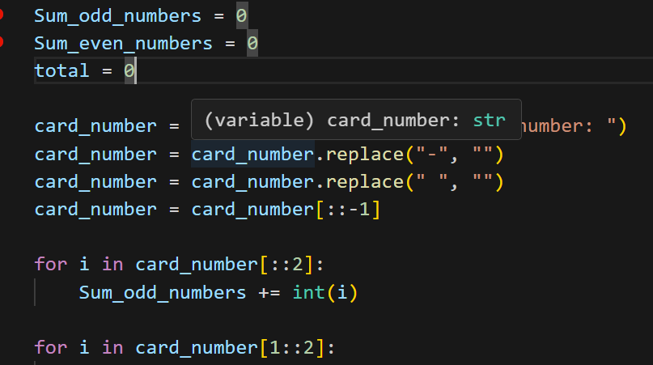

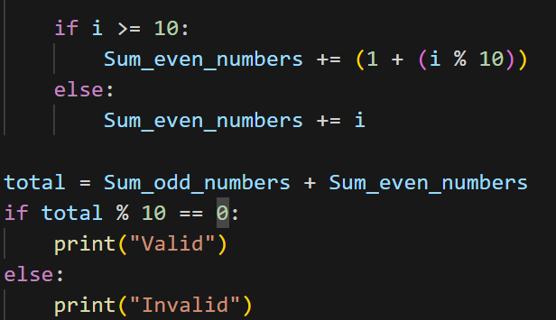

**2️⃣ Remove Punctuations from a Sentence**

* **The program asks the user to enter any word or sentence.**
* **It checks each character of the input.**
* **If the character is not a punctuation mark (like , . ! ? @ # $ etc.), it is added to a new string.**
* **As a result, all punctuation marks are removed, and only the clean text remains.**
* **Finally, the program prints the cleaned sentence without punctuations.**

**Example:**

* **Input → Hello, Haseeb! How are you**
* **Output → Hello Haseeb How are you**
* 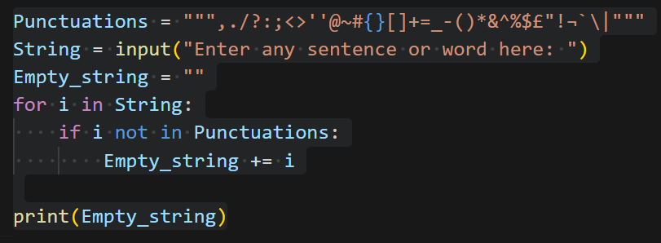

**3️⃣ ASCII Sorting of Words**

* **The program asks the user to enter a sentence.**
* **It splits the sentence into a list of words.**
* **Using the bubble sort algorithm, it compares the words based on their ASCII values (dictionary order).**
* **If a word is greater than the next word, they are swapped.**
* **This process continues until all words are arranged in ascending order.**
* **Finally, the program prints the sorted list of words.**

**Example:**

* **Input → my name is haseeb**
* **Output → ['haseeb', 'is', 'my', 'name']**
* 